# Lab 6 - Canvas

# Lab 6-1

Given the code for drawing a circle with radius 40 and center (45, 50) is :

<html>

<body>

<canvas id="myCanvas" width="200" height="100" style="border:1px solid #d3d3d3;">

Your browser does not support the HTML5 canvas tag.</canvas>

<script>

var c=document.getElementById("myCanvas");

var ctx=c.getContext("2d");

ctx.beginPath();

ctx.arc(45,50,40,0,2*Math.PI);

ctx.stroke();

</script>

</body>

</html>

Write the HTML5 code for the following output:

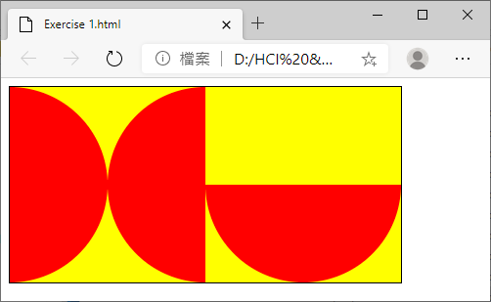

Rectangle: width=400, height=200, color=yellow.

Circles: radius=100, color=red.

# Lab 6-2

Given the following HTML5 code to produce the graphic ‘X’ as shown.

<canvas id="myCanvas" width="600" height="300" style="border:1px solid #d3d3d3;">

Your browser does not support the HTML5 canvas tag.</canvas>

<script>

var c=document.getElementById("myCanvas");

var ctx=c.getContext("2d");

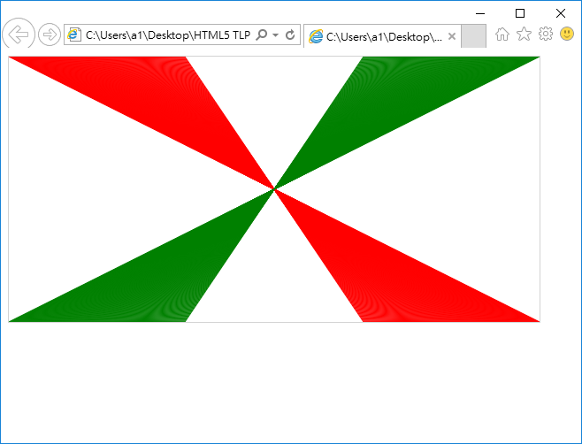ctx.strokeStyle="red";

for (var a = 0; a<200; a++) {

ctx.beginPath();

ctx.moveTo(a,0);

ctx.lineTo(600-a,300);

ctx.stroke();

ctx.closePath();

}

ctx.strokeStyle="green";

for (var a = 600; a>400; a--) {

ctx.beginPath();

ctx.moveTo(a,0);

ctx.lineTo(600-a,300);

ctx.stroke();

ctx.closePath();

}

</script>

Enhance the program to produce the graphic below:

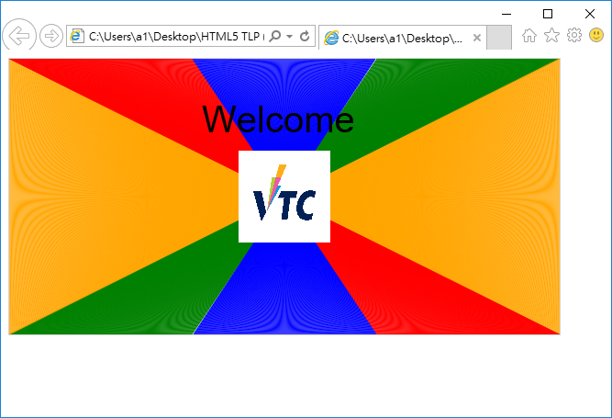

# Lab 6-3

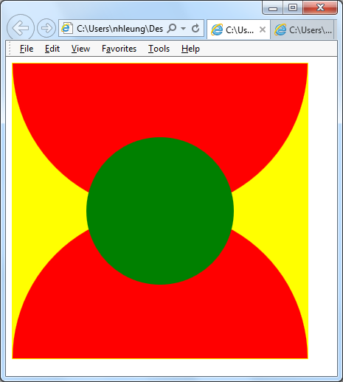

Write HTML5 code to display the diagram in the right.

Side of the rectangle is 400.

The radius of red circle is 200 and that of the green circle is 100.

# Lab 6-4

Write HTML5 code to display *similar* diagram below.

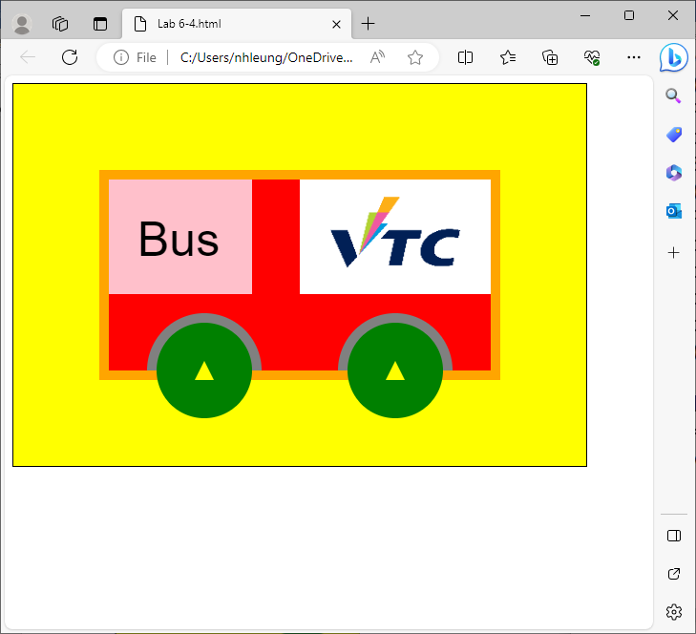

Steps for the diagram:

* Create yellow rectangular background
* Create orange rectangular bus border ( *ctx.lineWidth* )
* Create red rectangular bus body
* Create pink Driver seat with black Text “Bus”
* Create left green wheel with yellow axle
* Create right green wheel with yellow axle
* Create VTC logo using image